

COURSE PROJECT REPORT
Subject: SWD392

– Hanoi, October 2026 –

II. Requirement Specification

II.1 Problem description

II.1.1 Problem Statement
University students often buy and sell second-hand items such as textbooks, laptops, clothes and dorm supplies. Today they mostly do this in social media groups and private chats, which were not built for trading. This scattered way of working creates three main problems:
• Hard to Find the Right Item: Posts are mixed with many other messages in a group feed. Buyers cannot search by keyword or filter by price, category, condition or faculty/school, so they spend a lot of time and still miss good posts. Old and sold items also stay visible, so buyers keep asking about things that are no longer available.
• Low Trust Between Strangers: Nobody checks the posts, and there is no seller rating or easy way to report a scam. Buyers cannot tell whether a seller is reliable, and when a deal goes wrong, there is no official way to file a complaint.
• Messy Negotiation and No Deal Record: Price offers, agreements and receipt confirmation are spread across chats and comments. Nobody can easily see what was offered, what was agreed or what the status of a deal is, which leads to misunderstandings between buyer and seller.

II.1.2 Business Opportunity
Students are a large and active community, and many of them want to pass on items at the end of each semester and buy cheaper ones at the start of the next. A marketplace built just for them, with posts organized by category and by faculty/school, makes trading faster and keeps it in one place. Checked posts, seller ratings and a complaint process help students trust each other, so more deals are completed. Structured price offers and clear order statuses reduce arguments and wasted time. The platform can also earn income through the paid Post Boost service, where sellers pay to show their posts first, while normal posting and trading stay free.

Proposed Solution
Hola Student Marketplace (HSM) is an online marketplace that gathers all second-hand trading among students in one place. People use it in four roles: Guest (not logged in), Buyer, Seller and Admin. One account can be both Buyer and Seller. The system supports account management, posting, searching, chatting and commenting, price offers and orders, post boosting, and administration. It works with three outside services: an Email service to send verification codes, password reset links and notices; Google OAuth to let users log in with their Google account; and a Payment Gateway that automatically confirms Post Boost payments made by bank QR code.
Sellers publish posts and the Admin approves them before they appear to everyone. Buyers search, chat, send offers or buy now, then confirm receipt and review the seller. The Admin handles reports, complaints, locked accounts, payments and statistics. Routine tasks, such as hiding expired posts, expiring old offers and closing unanswered orders, run automatically.

II.1.3 Product Vision
For students who want to buy and sell second-hand items but struggle with scattered posts, untrusted sellers and messy negotiations, Hola Student Marketplace is an online marketplace that brings posting, searching, chatting, negotiating and ordering into one place. Unlike social media groups and private chats, HSM checks posts before they are shown, lets users search and filter by category, price, condition and faculty/school, keeps a clear record of offers and orders, and shows seller ratings and rankings. This helps students find what they need quickly, trade with more confidence, and lets the Admin keep the marketplace safe and well managed.

II.1.4 In Scope and Out of Scope

II.1.4.1 In Scope
The HSM system will provide a complete marketplace for second-hand trading among students. The main functions are:
• Account Management: Registering with email and password and verifying the email with a 6-digit code, logging in with email and password or Google, logging out, recovering and changing passwords, editing a personal profile, and viewing other users' profiles with their average rating and seller ranking.
• Post Management: Creating a post with a title, description, optional reference price, area, up to 10 images, category, condition and tags; submitting it for approval; editing or deleting it; marking it as For sale or Sold; renewing or reposting expired posts; viewing your history of viewed products; and sharing posts.
• Product Discovery: Searching by keyword, saving search history, filtering by price, category, area, condition and status, sorting by newest, price or views, and viewing post details with suggested similar products.
• Community Interaction: Chatting directly between buyer and seller, posting comments, saving favorite products, following other users, receiving in-app notifications, and reporting posts that break the rules.
• Trading: Sending, cancelling, accepting, rejecting and counter-offering price offers; creating orders with Buy now; seller confirmation or rejection; buyer confirmation of receipt; automatic completion or cancellation of orders; filing complaints; and reviewing the seller after the deal.
• Post Boost Service: Choosing a post and a 1-day, 7-day or 30-day package, paying by a QR code, automatic payment confirmation through the Payment Gateway, showing boosted posts first, and viewing boost statistics and purchase history.
• System Administration: Approving or rejecting posts, handling reports and complaints, warning, locking and unlocking users, handling the orders of locked accounts, reconciling payments, managing the receiving bank accounts for QR codes, configuring the system (categories, package prices, time periods), and viewing statistics.

II.1.4.2 Out of Scope
The following functions are not included in the current version of the HSM system:
• Payment for Trades: Buyer and seller agree on the final price, the payment method and how the item is received. The system does not process or hold this money and is not responsible for it. Only Post Boost fees are paid through the system.
• Delivery and Shipping: The system does not arrange delivery or connect to shipping companies. The buyer and the seller meet or deliver the item by themselves.
• Other Payment Methods for Boost Fees: Post Boost fees are paid only by bank QR code to the Admin's receiving account. Credit cards, e-wallets and other payment methods are not supported.
• Separate Moderator Role: The Moderator role is merged into the Admin role. There is no separate moderator account with its own permissions.
• Automatic Handling of Complaints: Complaints are reviewed and decided by the Admin, and the Admin's result is final in the system. There is no automatic judgment or outside dispute service.

II.2 Major Features
FE.1 Account Management: Lets users register by email (verified with an OTP) or log in with Google, reset or change their password, and update their profile. A seller’s profile shows their rating and ranking, and one account can both buy and sell.
FE.2 Post Management: Sellers publish an item with a description, reference price, area, condition, category and up to 10 images; an administrator approves it before it appears publicly. Sellers can edit, delete, mark as For sale or Sold, renew or repost; sold or expired posts are hidden automatically.
FE.3 Product Discovery: Helps people find the right item through keyword search, filters (price, category, area, condition) and sorting. The detail page suggests similar products, and guests can browse and search without logging in.
FE.4 Community Interaction: Users can message each other directly, comment, add favorites, follow one another and receive in-app notifications. Violating posts can be reported for an administrator to review.
FE.5 Trading: Buyers send a price offer (up to 3 negotiation rounds) or buy now, and the seller must confirm the order within 24 hours. The buyer confirms receipt; if they neither respond nor complain within 7 days, the order completes automatically, and either party can file a complaint within those 7 days, with the Admin making the final decision. HSM does not hold money, so the price and payment method are agreed by the two parties.
FE.6 Post Boost Service: Sellers pay a fee (1-, 7- or 30-day package) so their post is shown with priority. Payment is made by QR code and confirmed automatically, the package activates immediately, and sellers can see views, interactions and purchase history.
FE.7 System Administration: Admins approve posts, handle reports and complaints, warn or lock violating accounts, reconcile payments and manage the receiving accounts (Bank QR). They also configure the system and view statistics on users, products, orders and revenue.

II.3 Context Diagram 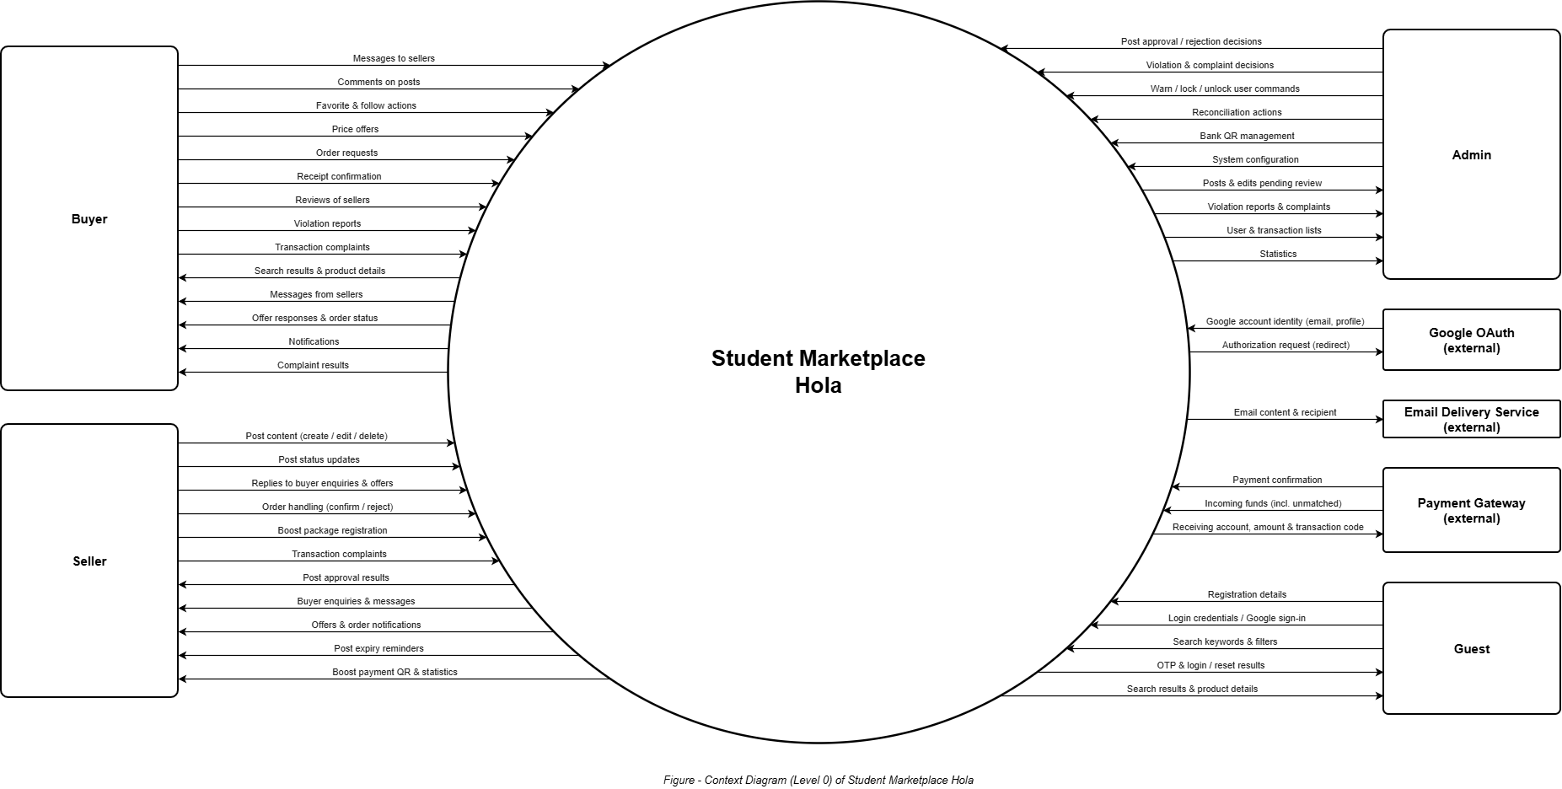

II.4 Nonfunctional requirements

ID | Feature | System Function | Description
1 | Performance | Search products (FE.3) | Search results (first 20 posts) appear within 2 seconds for 95% of searches, with up to 10,000 active posts.
2 | Performance | Refine results: filter, sort (FE.3) | Applying a filter or sort order updates the list within 2 seconds for 95% of requests.
3 | Performance | View product details (FE.3) | The product page is fully readable within 3 seconds on a 4G connection (5 Mbps) for 95% of views. Each image is compressed to 500 KB or less.
4 | Performance | Chat (FE.4) | A message reaches an online recipient within 1 second for 95% of messages.
5 | Performance | Receive notifications (FE.4) | An in-app notification appears within 5 seconds after the event happens.
6 | Performance | Register an account (FE.1) | The OTP email is sent within 30 seconds after the request for 95% of requests. The OTP stays valid for 5 minutes.
7 | Performance | Create a post (FE.2) | Submitting a post with 10 images (5 MB each) completes within 30 seconds on a 5 Mbps connection.
8 | Performance | Pay for a boost package (FE.6) | After the gateway reports a correct payment, the package is activated within 30 seconds, and the seller is notified in the same time.
9 | Performance | Scheduled jobs: offer expiry, order auto-cancel and auto-complete (FE.5) | Hourly jobs finish within 5 minutes. Every overdue offer or order is updated no later than 1 hour after its deadline (24 hours or 7 days).
10 | Performance | View statistics (FE.7) | The statistics page loads within 5 seconds with up to 100,000 records.
11 | Performance | Approve posts (FE.7) | The Admin approves or rejects 90% of new posts within 24 hours.
12 | Performance | Handle complaints (FE.7) | The Admin decides on 90% of complaints within 3 working days. The result is sent to both sides at once.
13 | Performance | Reconcile payments (FE.7) | Transactions in Pending reconciliation and unidentified funds are handled within 2 working days.
14 | Capacity | Whole system | The system serves 1,000 users online at the same time, with 100 requests per second, without exceeding the response times above.
15 | Availability | Whole system | The system is available 99.5% of each month (at most about 3.6 hours of downtime). Planned maintenance is done between 00:00 and 05:00 and announced 24 hours in advance.
16 | Reliability | Data backup | The database is backed up every day and kept for 30 days. After a failure, at most 24 hours of data is lost and service is restored within 4 hours.
17 | Reliability | Pay for a boost package, reconcile payments (FE.6, FE.7) | 100% of incoming funds reported by the gateway are recorded. A payment notification received twice is processed only once.
18 | Reliability | Buy now, handle orders, confirm receipt (FE.5) | An order is always in exactly one status. A status change is saved completely or not at all, so no order is lost or duplicated.
19 | Security | Log in, change password (FE.1) | Passwords have at least 8 characters and are stored only as hashes. After 5 wrong logins in a row, login is locked for 15 minutes.
20 | Security | Recover password (FE.1) | The reset link is valid for 15 minutes and works only once. The message never reveals whether an email is registered.
21 | Security | Log in, log out (FE.1) | A session ends automatically after 60 minutes without activity. Logging out ends it immediately.
22 | Security | Whole system | All traffic uses HTTPS (TLS 1.2 or higher). No personal data, such as email, is shown to other users.
23 | Security | Upload images: post, avatar, chat (FE.1, FE.2, FE.4) | Only JPG or PNG files up to 5 MB are accepted. Any other file is rejected with a clear message within 2 seconds.
24 | Security | Admin actions: approve, handle complaints, manage users, reconcile (FE.7) | 100% of Admin actions are logged (who, what, when) and kept for 12 months.
25 | Usability | Whole system | At least 90% of new users can register and publish their first post within 5 minutes, without any guide.
26 | Usability | Whole system | Every main function (search, post, chat, offer, order) is reachable within 3 clicks from the home page.
27 | Usability | Whole system | The interface works on screens from 360 px (phone) to 1920 px (desktop) wide. Every error message states the cause and how to fix it.
28 | Compatibility | Whole system | The system works on the latest 2 versions of Chrome, Edge, Firefox and Safari, and on Android 10+ and iOS 14+ browsers.
29 | Maintainability | Buy now, file a complaint (FE.5) | Order, complaint and payment records are kept for at least 3 years, even if the post is deleted.
30 | Maintainability | Configure the system (FE.7) | The Admin can change the offer period, post validity period, auto-complete period and boost package prices without redeploying. The change applies within 1 minute.

II.5 Functional requirements

II.5.1 Actors

ID | Actor | Description
1 | Guest | A user who is not logged in: views and searches products, registers an account, logs in, recovers a password.
2 | Buyer | A logged-in user looking to buy products: chats, comments, adds favorites, follows, sends price offers, buys now, confirms receipt, reviews, reports violations, files transaction complaints.
3 | Seller | A logged-in user who publishes posts to sell items: creates, edits and renews posts, updates status, responds to price offers, handles orders, buys post boost packages, files transaction complaints.
4 | Admin | Administrator (Moderator role merged in): approves posts, handles reports and complaints, warns or locks accounts, handles frozen orders of locked accounts, manages Bank QR, reconciles payments (including unidentified incoming funds), configures the system, views statistics.
5 | Email | The system’s email delivery service: sends OTPs, password recovery links and important emails (violation reports, successful post boost payments, complaint results, accounts warned or locked).
6 | Google OAuth | An external authentication service that allows logging in with a Google account.
7 | Payment Gateway | The payment gateway that processes, checks and automatically confirms post boost service fee payments; reports to the system every incoming fund to the receiving account, including funds that do not match any transaction code.

II.5.2 Use Cases

II.5.2.1 Use Case Diagram(s)

a. System boundary diagram

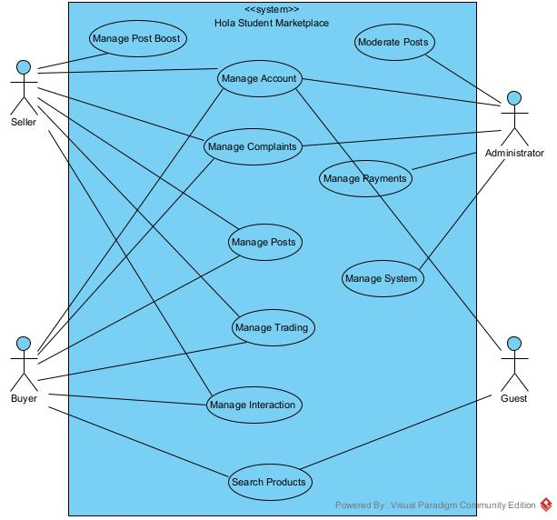

b. Account management

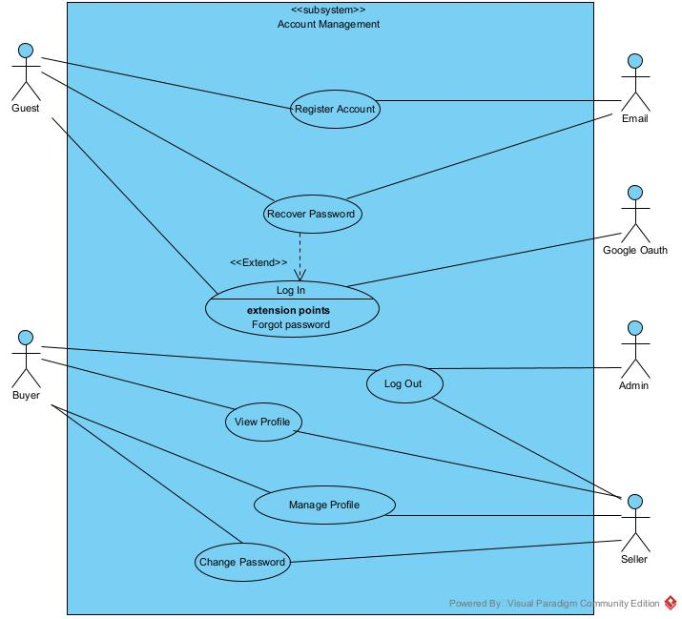

II.5.2.2 Use case descriptions

a. Use case descriptions

ID | Use Case | FE ID | Actors | Use Case Description
UC.1 | Register an account | FE.1 | Guest; Email | A guest creates an account with email and password, receives a 6-digit OTP by email for verification, and can request the code to be resent.
UC.2 | Log in | FE.1 | Guest, Admin; Google OAuth | A user logs in with email and password, or with a Google account. On the first Google login the system creates the account automatically.
UC.3 | Log out | FE.1 | Buyer, Seller, Admin | A logged-in user ends the session. The system terminates the session and returns the user to the Guest role.
UC.4 | Recover password | FE.1 | Guest; Email | A user who forgot the password requests a reset link by email, then sets a new password. Accounts created via Google use this function to set a first password.
UC.5 | Change password | FE.1 | Buyer, Seller, Admin | A logged-in user who already has a password replaces the current password with a new one.
UC.6 | Manage profile | FE.1 | Buyer, Seller | A user updates the avatar, cover photo, bio and nickname.
UC.7 | View profile | FE.1 | Buyer, Seller | A user views another user’s profile, including the average rating and the seller ranking.
UC.8 | Create a post | FE.2 | Seller | A seller enters product information and an optional reference price, selects an area, uploads up to 10 images, selects a category and a condition, and adds tags. The seller then submits the post for Admin approval.
UC.9 | Edit a post | FE.2 | Seller | A seller edits or deletes their own post and views its approval status. Editing an approved post’s content creates an edit pending Admin approval, and the post keeps displaying the approved content meanwhile. Editing only the price takes effect immediately.
UC.10 | Update post status | FE.2 | Seller | A seller switches a post between For sale and Sold. A Sold post is automatically hidden from the public list.
UC.11 | Renew a post | FE.2 | Seller | A post older than X days since approval is automatically hidden (checked daily). The seller renews a post about to expire or reposts an expired post.
UC.12 | Share a post | FE.2 | Buyer, Seller, Guest | A user shares a post via link or social networks.
UC.13 | View viewing history | FE.2 | Buyer | A buyer revisits the list of products they recently viewed.
UC.14 | Search products | FE.3 | Guest, Buyer | A user performs a full-text search on title, description and tags. The system saves the keyword to the search history of logged-in users.
UC.15 | Refine results | FE.3 | Guest, Buyer | A user narrows results by price range, category, area, condition and status, and sorts by newest, price or view count.
UC.16 | View product details | FE.3 | Guest, Buyer | A user views the full post information, images, seller, comments and suggested similar products. The system increases the view count and records the view in the viewing history.
UC.17 | Manage search history | FE.3 | Buyer | A buyer views and deletes the keywords they have searched.
UC.18 | Chat | FE.4 | Buyer, Seller | A buyer and a seller message each other directly in real time: sending images, using quick messages, and marking as read.
UC.19 | Comment on a product | FE.4 | Buyer, Seller | A user posts a public comment under a post, and edits or deletes their own comments.
UC.20 | Manage favorites | FE.4 | Buyer | A buyer adds and removes favorite products and views the favorites list.
UC.21 | Follow users | FE.4 | Buyer | A buyer follows and unfollows other users and views the feed of posts from the users they follow.
UC.22 | Receive notifications | FE.4 | Buyer, Seller; Email | The system sends in-app notifications for events such as messages, offers, post approval, orders, complaints and boost payments. Email is used only for authentication, violation reports, successful boost payments, complaint results, and warned or locked accounts.
UC.23 | Report a violation | FE.4 | Buyer, Seller | A user submits a report with a reason for a violating post.
UC.24 | Price offer | FE.5 | Buyer | A buyer sends a proposed price for a post and can cancel the offer. An offer automatically expires after 7 days (checked hourly).
UC.25 | Respond to a price offer | FE.5 | Seller, Buyer | The seller accepts, rejects or counter-offers. The buyer then responds to the counter price.
UC.26 | Buy now | FE.5 | Buyer | A buyer creates an order directly. The final price, receiving method and payment method are agreed by the two parties themselves; the system does not process payment.
UC.27 | Handle orders | FE.5 | Seller | A seller confirms or rejects the order. An order pending confirmation for more than 24 hours is automatically cancelled (checked hourly).
UC.28 | Confirm receipt | FE.5 | Buyer | The buyer confirms receipt after the seller confirms the order. The order moves to Completed, the post moves to Sold and the buyer can review the transaction. If the buyer neither confirms nor files a complaint within 7 days of the seller’s confirmation, the order is auto-completed. An order frozen because of an account lock is not auto-completed.
UC.29 | File a complaint | FE.5 | Buyer, Seller; Email | Either party files a complaint about the transaction before the fixed complaint deadline (7 days from the seller’s confirmation) and receives the handling result by notification and email.
UC.30 | Review a transaction | FE.5 | Buyer | The buyer reviews the seller after the order is completed. The score is added to the seller’s reputation.
UC.31 | Register a post boost package | FE.6 | Seller | A seller selects the post to boost and chooses a 1-day, 7-day or 30-day package. The package automatically expires when its term ends (checked hourly) and the post stops being prioritized.
UC.32 | Pay for a post boost package | FE.6 | Seller; Payment Gateway , Email | The system generates a QR code from the Admin’s receiving account, with the amount and transaction code. The gateway confirms the payment automatically and the package is activated immediately. A transaction with no funds after 24 hours becomes Expired, while late funds matching the transaction code are still recorded and activate the package if the post is eligible. The seller is notified, and an email is also sent on success.
UC.33 | Track boost effectiveness | FE.6 | Seller | A seller views the views and interactions of the boosted post and the package purchase history.
UC.34 | Approve posts | FE.7 | Admin | The Admin views new posts and edits pending approval, then approves valid ones or rejects them with a reason. An approved edit replaces the displayed content, and a rejected edit leaves the old content unchanged.
UC.35 | Handle reports | FE.7 | Admin; Email | The Admin views violation reports, removes violating posts or dismisses invalid reports, then emails the result to the reporter (and to the post owner if the post is removed).
UC.36 | Handle complaints | FE.7 | Admin; Email | The Admin views transaction complaints, makes a decision and notifies both parties of the result by in-app notification and email.
UC.37 | Manage users | FE.7 | Admin; Email | The Admin searches users and warns, locks or unlocks accounts, and the affected user receives an email. When an account is locked, its pending orders and ongoing offers are automatically cancelled, and its Confirmed orders are frozen for the Admin to handle.
UC.38 | Reconcile payments | FE.7 | Admin; Payment Gateway | The Admin monitors boost fee transactions and handles those in Pending reconciliation status (refund or manual activation) and unidentified incoming funds (assign to a transaction or refund).
UC.39 | Manage receiving accounts | FE.7 | Admin | The Admin adds, edits, and enables or disables the receiving accounts (bank account numbers) used to generate QR codes for boost fees.
UC.40 | Configure the system | FE.7 | Admin | The Admin manages categories, boost package prices, the offer period, the post validity period and the order auto-completion period.
UC.41 | View statistics | FE.7 | Admin | The Admin views overview statistics (users, products, orders) and detailed revenue statistics.

1. UC.1 Register an account
UC ID and Name: | UC.1 Register an account
Created By: | NhatNM | Date Created: | 06/10/2026
Primary Actor: | Guest | Secondary Actors: | Email
Trigger: | The Guest selects “Register” on the home or login screen.
Description: | A guest creates an account with email and password, receives a 6-digit OTP by email for verification, and can request the code to be resent.
Preconditions: | 1. The user is not logged in.  2. The email has not been registered (BR.1).
Postconditions: | 1. A new account is created and its email is verified (BR.1).  2. The user can use the functions intended for logged-in users.
Normal Flow: | 1. The Guest opens the registration form.  2. The Guest enters email and password and submits.  3. The system checks that the email is unique (BR.1) and that the password has at least 8 characters with letters and digits (BR.2).  4. The system creates the account as unverified and asks the Email service to send a 6-digit OTP.  5. The Email service sends the OTP to the entered email.  6. The Guest enters the OTP.  7. The system checks that the OTP is correct, unused and within 5 minutes (BR.1).  8. The system marks the email as verified and notifies the Guest that registration succeeded.
Alternative Flows: | A1. Resend the OTP (at step 6):  1. The Guest selects “Resend code”.  2. If at least 60 seconds have passed since the last sending, the system invalidates the old code and sends a new one (BR.1).  3. The flow continues from step 6.
Exceptions: | E1. The email is already registered (step 3): the system shows an error and suggests logging in.  E2. The password does not meet the rule (step 3): the system shows the rule.  E3. The OTP is wrong or expired (step 7): the system shows an error; after more than 5 wrong entries, the Guest must request a new code (BR.1).  E4. The Guest asks for a resend before 60 seconds have passed: the system rejects it and shows the waiting time.  E5. The email cannot be delivered: the system informs the Guest, who can request a resend.
Priority: | High
Frequency of Use: | Once for each user, when joining the system
Business Rules: | BR.1, BR.2, BR.7
Other Information: | The OTP has 6 digits and is valid for 5 minutes. Admin accounts are issued by the system and do not use this function (BR.7).
Assumptions: | The Guest can access the mailbox of the entered email. The Email service is available.

UC.2 Log in
UC ID and Name: | UC.2 Log in
Created By: | NhatNM | Date Created: | 06/10/2026
Primary Actor: | Guest, Admin | Secondary Actors: | Google OAuth
Trigger: | The user selects “Log in”.
Description: | A user logs in with email and password, or with a Google account. On the first Google login the system creates the account automatically.
Preconditions: | 1. The user is not logged in.  2. The account is not locked (BR.5).
Postconditions: | 1. A session is created for the user.  2. The user can use the functions of their role.
Normal Flow: | Login with email and password:  1. The user opens the login screen and enters email and password.  2. The system checks the email and password.  3. The system checks that the account is not locked (BR.5).  4. The system creates a session and opens the home screen.
Alternative Flows: | A1. Login with Google:  1. The user selects “Log in with Google”.  2. The system redirects the user to Google OAuth for authorization.  3. The user authorizes; Google OAuth returns the user’s profile and ID token.  4. If the Google email matches an existing account, the system links to that account. Otherwise, it creates a new account with a verified email (BR.3).  5. The flow continues from step 3 of the normal flow.  A2. Forgot password: at step 1, the user selects “Forgot password” and moves to UC.4.
Exceptions: | E1. Wrong email or password (step 2): the system shows an error.  E2. More than 5 consecutive failed logins: login is temporarily locked for 15 minutes (BR.5).  E3. The account is locked (step 3): the system shows an account-locked message (BR.5).  E4. The account has no password (created via Google) but the user logs in with email and password: the system rejects it and suggests logging in with Google or setting a password through Recover password (BR.3).  E5. Google authorization is denied or fails: the system returns to the login screen with a message.
Priority: | High
Frequency of Use: | Many times a day, at the start of each working session
Business Rules: | BR.3, BR.5, BR.7
Other Information: | Admin accounts are issued by the system and log in on the same screen (BR.7).
Assumptions: | The Google OAuth service is available.

UC.3 Log out
UC ID and Name: | UC.3 Log out
Created By: | NhatNM | Date Created: | 06/10/2026
Primary Actor: | Buyer, Seller, Admin | Secondary Actors: | None
Trigger: | The user selects “Log out”.
Description: | A logged-in user ends the session. The system terminates the session and returns the user to the Guest role.
Preconditions: | The user is logged in.
Postconditions: | 1. The current session is terminated.  2. The user has only Guest permissions (BR.41).
Normal Flow: | 1. The user selects “Log out”.  2. The system terminates the current session.  3. The system returns the user to the home screen as a Guest.
Alternative Flows: | None.
Exceptions: | E1. The session has already expired: the system simply shows the user as a Guest.
Priority: | Medium
Frequency of Use: | Once at the end of each working session
Business Rules: | BR.41
Other Information: | Only the current session is ended.
Assumptions: | None.

UC.4 Recover password
UC ID and Name: | UC.4 Recover password
Created By: | NhatNM | Date Created: | 06/10/2026
Primary Actor: | Guest | Secondary Actors: | Email
Trigger: | The user selects “Forgot password” on the login screen.
Description: | A user who forgot the password requests a reset link by email, then sets a new password. Accounts created via Google use this function to set a first password.
Preconditions: | 1. The user is not logged in.  2. The user knows the registered email.
Postconditions: | 1. The new password is saved in hashed form (BR.2).  2. The reset link can no longer be used (BR.4).  3. The user can log in with email and password.
Normal Flow: | 1. The user enters the registered email on the recovery screen.  2. The system shows the same message whether or not the email exists (BR.4).  3. If the email is registered, the system creates a single-use link valid for 15 minutes and asks the Email service to send it (BR.4).  4. The Email service sends the link to the registered email.  5. The user opens the link and enters a new password and its confirmation.  6. The system checks the link and the password rule (BR.2).  7. The system saves the new password and shows a success message.
Alternative Flows: | A1. Account created via Google (no password yet): the flow is the same. The link is sent to the verified email, and the user sets a first password. Afterwards the account can log in with both Google and email and password (BR.4).
Exceptions: | E1. The email is not registered (step 2): the same message is shown and no email is sent.  E2. The link is expired or already used (step 6): the system shows an error and the user requests a new link.  E3. The new password does not meet the rule (step 6): the system shows the rule.  E4. The password and its confirmation do not match: the system asks the user to enter them again.
Priority: | Medium
Frequency of Use: | Occasionally
Business Rules: | BR.2, BR.4
Other Information: | The reset link is valid for 15 minutes and works only once.
Assumptions: | The user can access the mailbox of the registered email.

UC.5 Change password
UC ID and Name: | UC.5 Change password
Created By: | NhatNM | Date Created: | 06/10/2026
Primary Actor: | Buyer, Seller | Secondary Actors: | None
Trigger: | The user selects “Change password” in the account settings.
Description: | A logged-in user who already has a password replaces the current password with a new one.
Preconditions: | 1. The user is logged in.  2. The account already has a password (BR.4).
Postconditions: | The password is replaced by the new one, stored in hashed form (BR.2).
Normal Flow: | 1. The user opens the “Change password” screen.  2. The user enters the current password, the new password and its confirmation.  3. The system checks that the current password is correct (BR.2).  4. The system checks that the new password differs from the old one and meets the rule (BR.2).  5. The system saves the new password and shows a success message.
Alternative Flows: | None.
Exceptions: | E1. The current password is wrong (step 3): the system shows an error.  E2. The new password is the same as the old one (step 4): the system rejects it.  E3. The new password does not meet the rule (step 4): the system shows the rule.  E4. The account has no password (created via Google): this function is not available, and the user uses Recover password instead (BR.4).
Priority: | Medium
Frequency of Use: | Rarely
Business Rules: | BR.2, BR.4
Other Information: | None.
Assumptions: | None.

UC.6 Manage profile
UC ID and Name: | UC.6 Manage profile
Created By: | NhatNM | Date Created: | 06/10/2026
Primary Actor: | Buyer, Seller | Secondary Actors: | None
Trigger: | The user selects “Edit profile”.
Description: | A user updates the avatar, cover photo, bio and nickname.
Preconditions: | The user is logged in.
Postconditions: | The profile is updated and shown with the new information.
Normal Flow: | 1. The user opens the profile editing screen.  2. The user changes the avatar, cover photo, bio or nickname.  3. The user saves the changes.  4. The system checks the data: the nickname is required; images are JPG or PNG, up to 5 MB (BR.6).  5. The system saves the changes and shows the updated profile.
Alternative Flows: | A1. The user changes only some of the items; the other items keep their current values.
Exceptions: | E1. The nickname is empty (step 4): the system asks the user to enter it.  E2. An image is not JPG or PNG (step 4): the system rejects the image.  E3. An image is larger than 5 MB (step 4): the system rejects the image.  E4. The upload fails: the system shows an error and keeps the old information.
Priority: | Medium
Frequency of Use: | Occasionally
Business Rules: | BR.6
Other Information: | Applies to both avatar and cover photo.
Assumptions: | None.

UC.7 View profile
UC ID and Name: | UC.7 View profile
Created By: | NhatNM | Date Created: | 06/10/2026
Primary Actor: | Buyer, Seller | Secondary Actors: | None
Trigger: | The user selects another user’s name or avatar (for example on a post or in a chat).
Description: | A user views another user’s profile, including the average rating and the seller ranking.
Preconditions: | 1. The user is logged in.  2. The viewed account exists.
Postconditions: | The profile is displayed. No data is changed.
Normal Flow: | 1. The user selects another user’s profile.  2. The system gets the avatar, cover photo, bio and nickname.  3. The system calculates the average rating and the seller ranking from the reviews received (BR.30).  4. The system displays the profile.
Alternative Flows: | A1. The user views their own profile: the flow is the same.
Exceptions: | E1. The seller has no reviews yet: the system shows “No rating yet”.  E2. The profile cannot be loaded: the system shows an error message.
Priority: | Medium
Frequency of Use: | Often, before buying from or chatting with a seller
Business Rules: | BR.30
Other Information: | The average rating and ranking come from the reviews that buyers give after completed orders.
Assumptions: | None.

III. Analysis models.

III.1. High-level class diagram (structural models)
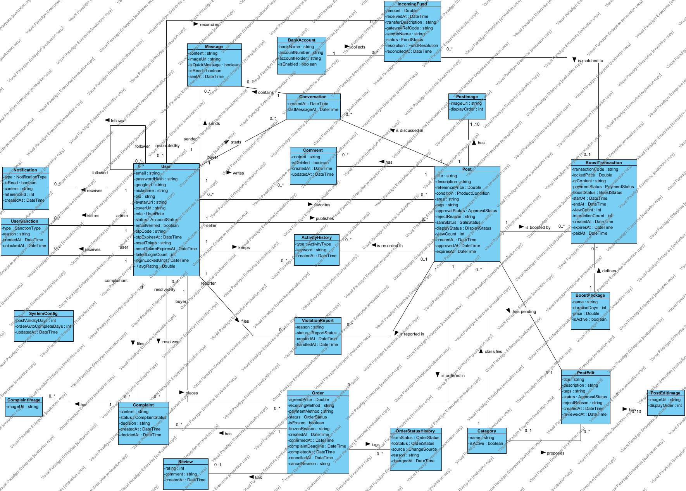

Relationships (associations)
# | Class A [multiplicity] | Association | Class B [multiplicity] | Explanation
1 | User (seller) [1] | publishes | Post [0..*] | Every post is published by exactly one user acting as the seller. A user may publish many posts or none at all.
2 | Category [1] | classifies | Post [0..*] | Every post belongs to exactly one category. A category may contain many posts or none yet.
3 | Post [1] | has | PostImage [1..10] | A post must have at least 1 and at most 10 images. Each image belongs to exactly one post.
4 | Post [1] | has pending | PostEdit [0..1] | A post can have at most one pending edit version at a time. The post keeps showing its approved content until the Admin approves the edit.
5 | User [0..*] | favorites | Post [0..*] | A user can add many posts to their favorites, and a post can be favorited by many users (many-to-many).
6 | User (follower) [0..*] | follows | User (followed) [0..*] | A user can follow many other users and can be followed by many users. This is a many-to-many association from User to itself.
7 | User [1] | writes | Comment [0..*] | Every comment is written by exactly one user. A user may write many comments.
8 | Post [1] | has | Comment [0..*] | Every comment belongs to exactly one post. A post may have many comments or none.
9 | User [1] | keeps | ActivityHistory [0..*] | Each activity record (viewed post or search keyword) belongs to exactly one user, and a user may have many records.
10 | Post [0..1] | is recorded in | ActivityHistory [0..*] | An activity record may refer to a post, as in the viewing history, or to no post, as in a keyword search. A post can appear in many activity records.
11 | User [1] | receives | Notification [0..*] | Every notification is sent to exactly one user. A user may receive many notifications.
12 | User (user) [1] | receives | UserSanction [0..*] | Every sanction is applied to exactly one user (the sanctioned user). A user may receive several sanctions over time.
13 | Post [1] | is discussed in | Conversation [0..*] | Every conversation is about exactly one post. A post may be discussed in many conversations, for example one per interested buyer.
14 | User (buyer) [1] | starts | Conversation [0..*] | Every conversation is started by exactly one buyer. A user may start many conversations.
15 | Conversation [1] | contains | Message [0..*] | Every message belongs to exactly one conversation. A conversation contains many messages.
16 | User (sender) [1] | sends | Message [0..*] | Every message has exactly one sender. A user may send many messages.
17 | User (buyer) [1] | places | Order [0..*] | Every order is placed by exactly one buyer. A user may place many orders.
18 | Post [1] | is ordered in | Order [0..*] | Every order is for exactly one post. A post may be linked to several orders or to none.
19 | Order [1] | logs | OrderStatusHistory [0..*] | Every status change of an order is recorded as a history entry. Each entry belongs to exactly one order.
20 | Order [1] | has | Review [0..1] | An order may have at most one review, written by the buyer after the transaction. A review belongs to exactly one order.
21 | Order [1] | has | Complaint [0..*] | An order may have no complaint, one or several. Each complaint relates to exactly one order.
22 | User (complainant) [1] | files | Complaint [0..*] | Every complaint is filed by exactly one user (the complainant). A user may file many complaints.
23 | User (reporter) [1] | files | ViolationReport [0..*] | Every violation report is filed by exactly one user (the reporter). A user may file many reports.
24 | Post [1] | is reported in | ViolationReport [0..*] | Every violation report targets exactly one post. A post may be reported many times or never.
25 | BoostPackage [1] | defines | BoostTransaction [0..*] | Every boost transaction is based on exactly one package, which defines its duration and price. A package may be used in many transactions.
26 | Post [1] | is boosted by | BoostTransaction [0..*] | Every boost transaction is for exactly one post. A post may have many boost transactions over time.
27 | IncomingFund [0..*] | is matched to | BoostTransaction [0..1] | An incoming fund is matched to at most one boost transaction. It stays unmatched while it cannot be identified. A transaction can be matched with several incoming funds.
28 | BankAccount [1] | collects | IncomingFund [0..*] | Every incoming fund is received in exactly one receiving bank account. A bank account may collect many funds.
29 | PostEdit [1] | has | PostEditImage [0..10] | An edit version may carry up to 10 images, or none if the images are not changed. Each image belongs to exactly one edit version.
30 | Complaint [1] | has | ComplaintImage [0..*] | A complaint may include any number of evidence images, or none. Each image belongs to exactly one complaint.
31 | Category [0..1] | proposes | PostEdit [0..*] | An edit version may propose a new category, and this is optional. A category may be proposed in many edit versions.
32 | User (admin) [1] | issues | UserSanction [0..*] | Every sanction is issued by exactly one Admin. An Admin may issue many sanctions.
33 | User (resolvedBy) [0..1] | resolves | Complaint [0..*] | A complaint is resolved by one Admin once a decision is made. Until then it has no resolver. An Admin may resolve many complaints.
34 | User (reconciledBy) [0..1] | reconciles | IncomingFund [0..*] | An incoming fund is reconciled by one Admin after the check. Before that it has no reconciler. An Admin may reconcile many funds.

III.2 Interaction diagrams

III.2.1.Sequence Diagrams
- UC-01 Register an account
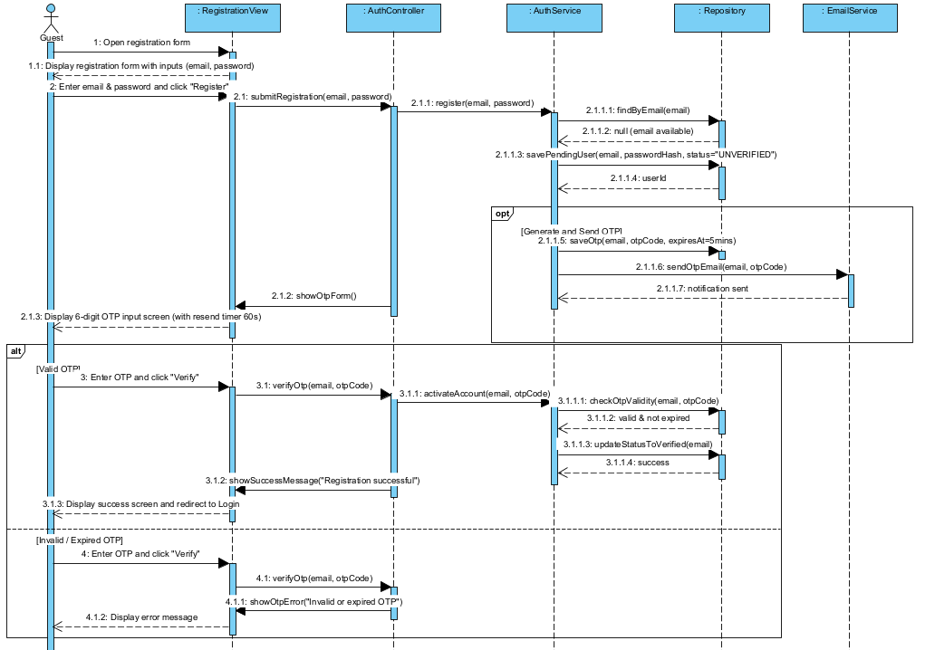
- UC-02 Log in
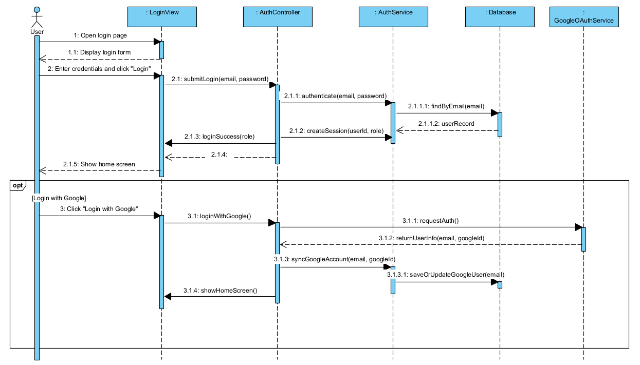
- UC-03 Log out
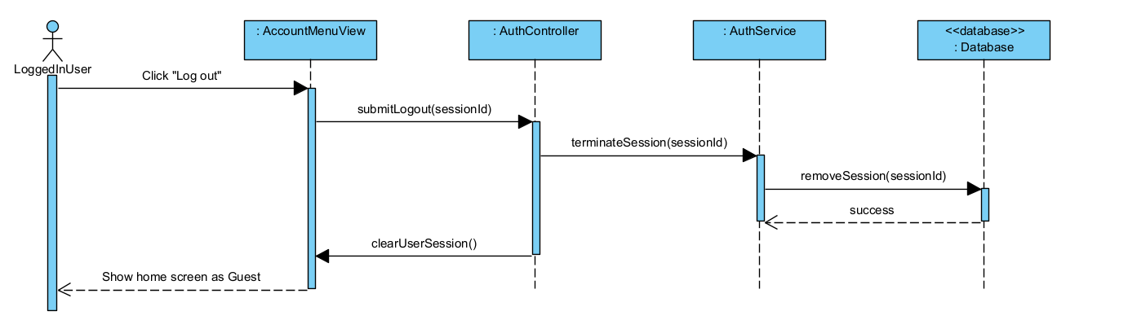
- UC-04 Recover password
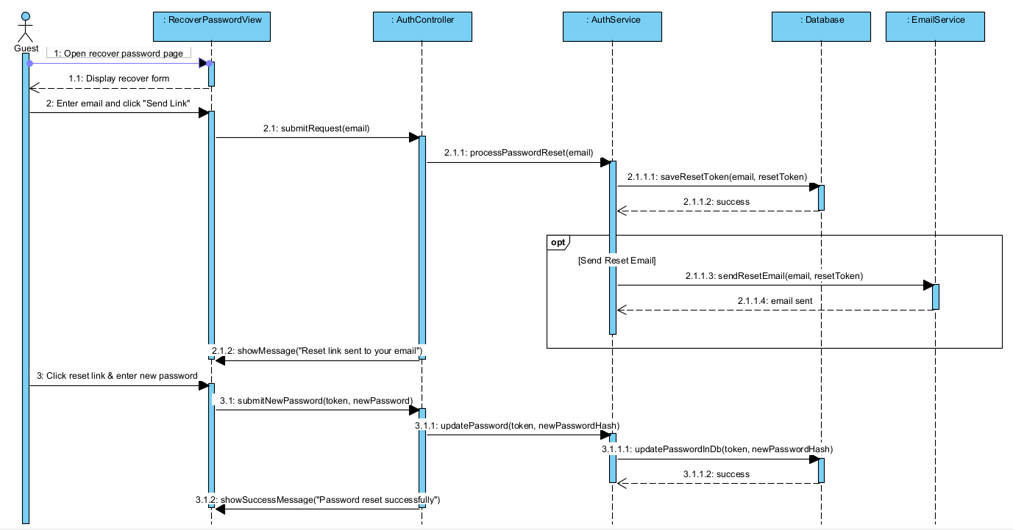
- UC-05 Change password
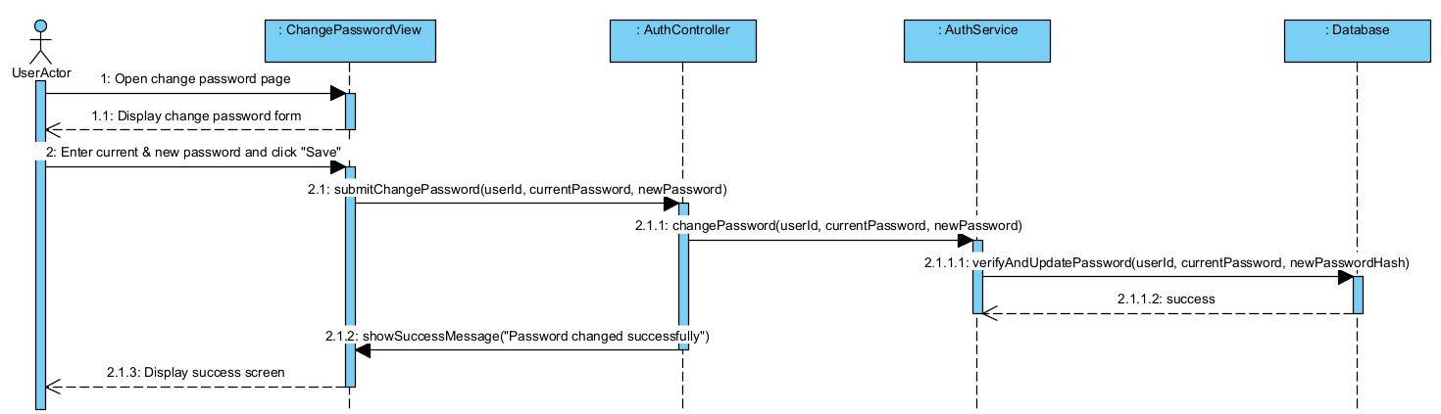
- UC-06 Manage profile
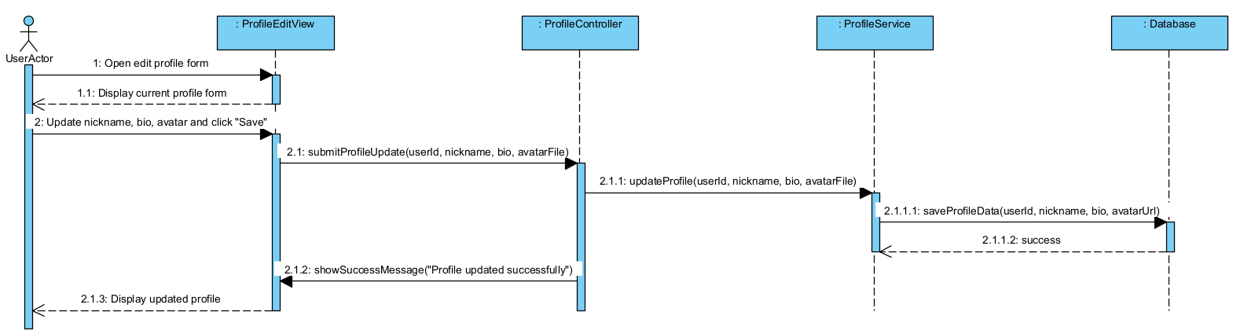
- UC-07 View profile
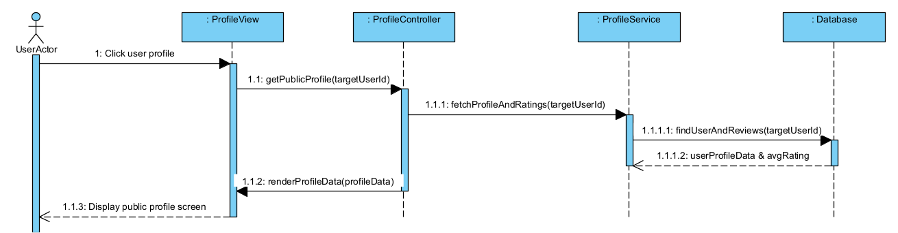

III.2.2. Communication Diagrams

- UC-01 Register an account
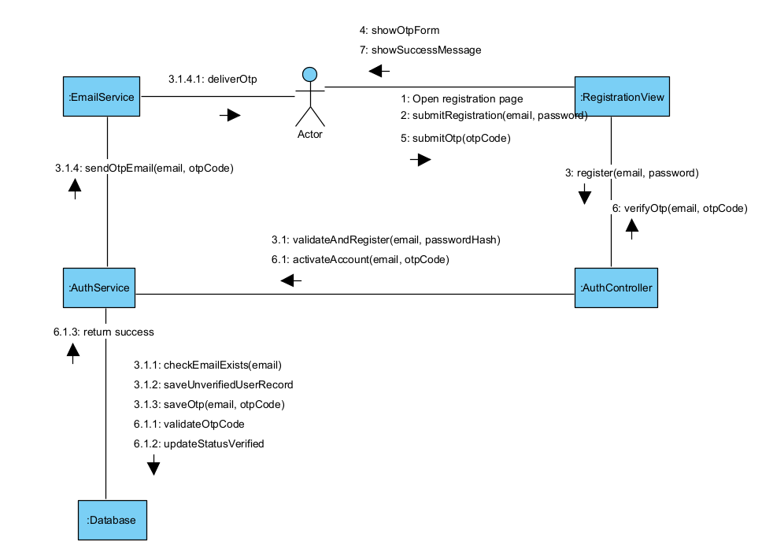
- UC-02 Log in
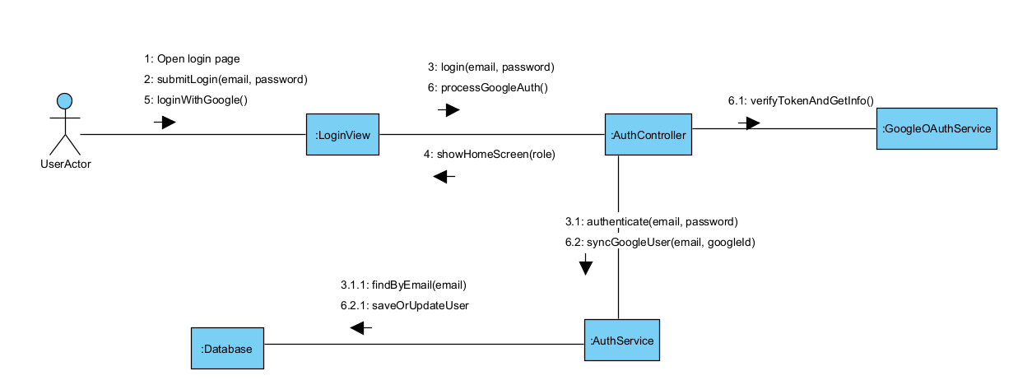
- UC-03 Log out
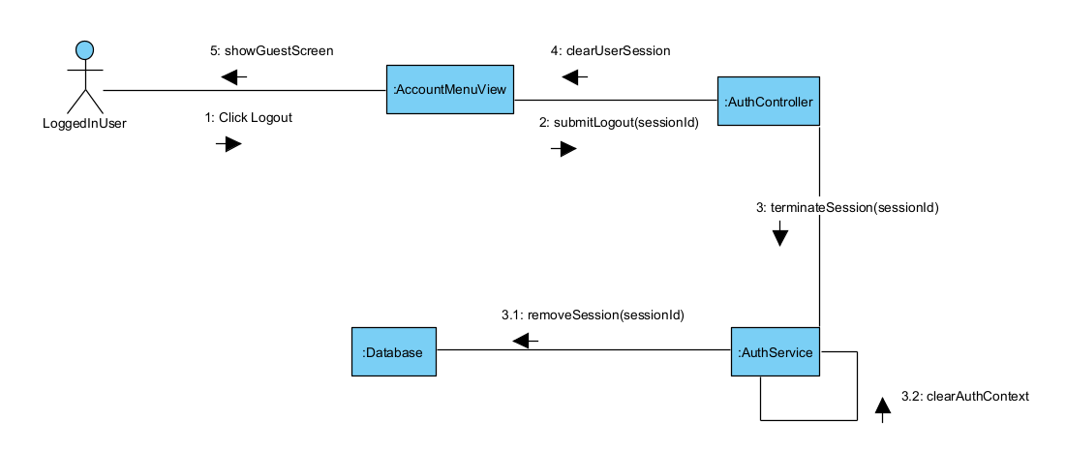
- UC-04 Recover password
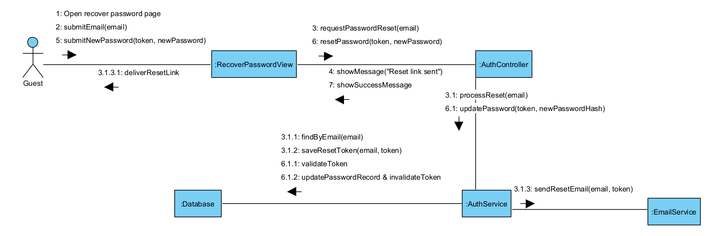
- UC-05 Change password
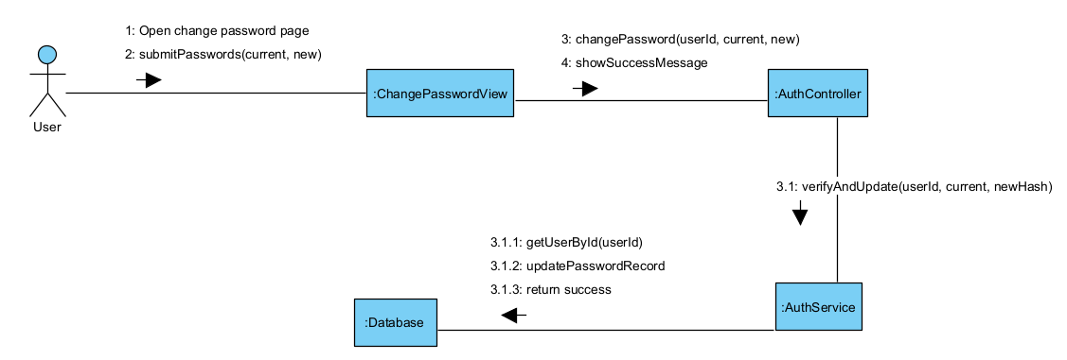
- UC-06 Manage profile
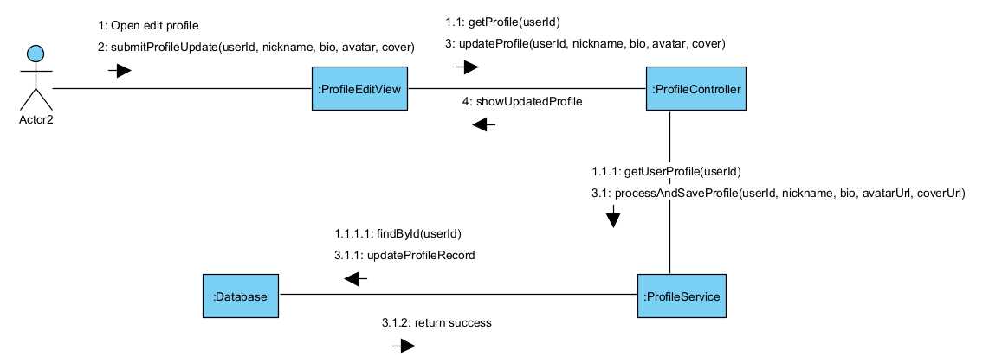
- UC-07 View profile
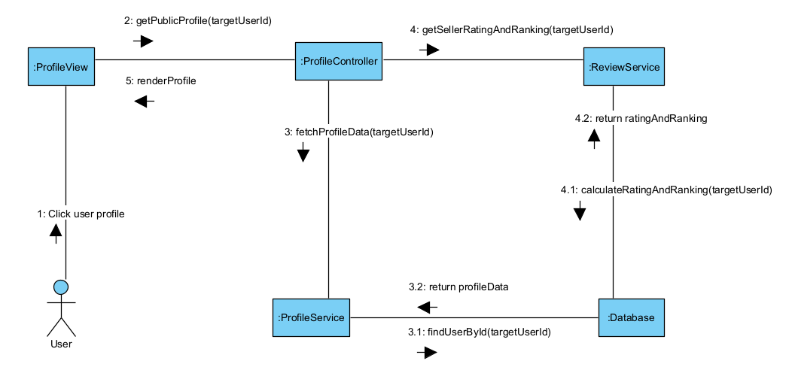

a. Post State Diagram

Approval Status

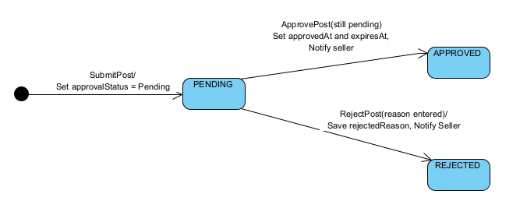

Stage | State | Actor | What happens
1. Creation | Initial → PENDING | Seller | The Seller fills in the product information, selects a category, uploads 1 to 10 images and submits the post. The system creates the Post with approvalStatus = PENDING. The post is not shown to the public until the Admin approves it.
2. Waiting for review | PENDING | Admin | The post waits in the moderation queue. The Admin reviews the content and images and decides whether to approve or reject the post.
3a. Post is approved | PENDING → APPROVED | Admin | The Admin approves the post. The system records approvedAt, sets expiresAt = approvedAt + postValidityDays, makes the post visible to the public and notifies the Seller.
3b. Post is rejected | PENDING → REJECTED | Admin | The Admin must enter a reason. The system saves rejectReason, keeps the post hidden from the public and notifies the Seller with the reason.
4. End of lifecycle | APPROVED or REJECTED | None | The post does not move on and approvalStatus never changes again. Later changes to an approved post are handled by the PostEdit lifecycle. The record is kept as history.

SaleStatus

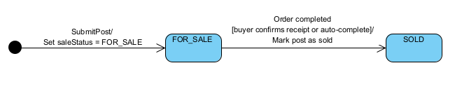

Stage | State | Actor | What happens
1. Creation | Initial → FOR_SALE | Seller | When the Seller submits a new post, the system creates the Post with saleStatus = FOR_SALE.
2. Available for sale | FOR_SALE | Buyer / Seller | The post is shown as still available. Buyers can chat with the Seller and place an order with Buy now. Money is exchanged outside the system.
3. Item is sold | FOR_SALE → SOLD | System | When the Buyer confirms receipt of the goods, or the order is completed automatically after orderAutoCompleteDays, the Order becomes COMPLETED and the system changes saleStatus to SOLD.
4. End of lifecycle | SOLD | None | The post is marked as sold and saleStatus does not change again. The record is kept for order history and statistics.

DisplayStatus

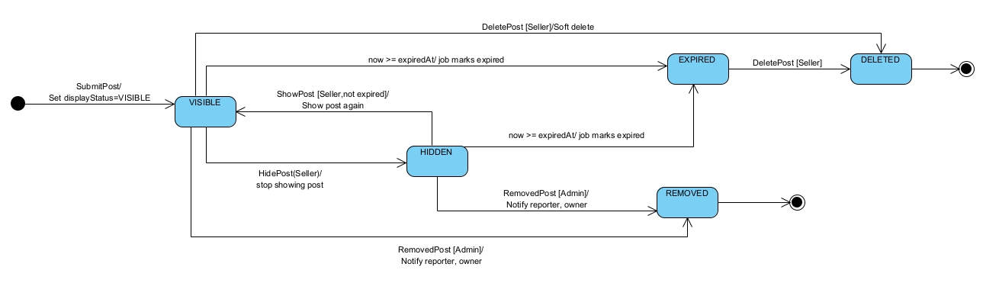

Stage | State | Actor | What happens
1. Creation | Initial → VISIBLE | Seller | When the Seller submits a new post, the system creates the Post with displayStatus = VISIBLE. The post is shown to the public only after approvalStatus becomes APPROVED.
2. Showing to the public | VISIBLE | System | An approved post appears in search results and listings until it is hidden, expires, is removed or is deleted.
3a. Seller hides the post | VISIBLE → HIDDEN | Seller | The Seller temporarily hides the post. It no longer appears in search results or listings, but its data is kept.
3b. Seller shows the post again | HIDDEN → VISIBLE | Seller | The Seller shows the hidden post again. This is allowed only while the post has not expired, been removed or been deleted.
4. Post expires | VISIBLE or HIDDEN → EXPIRED | System | When the current time reaches expiresAt, the scheduled job changes displayStatus to EXPIRED. The post is no longer shown to the public.
5. Post is removed | VISIBLE or HIDDEN → REMOVED | Admin | After a valid ViolationReport, the Admin removes the post. displayStatus changes to REMOVED, and the system emails the reporter and the post owner.
6. Post is deleted | VISIBLE, HIDDEN or EXPIRED → DELETED | Seller | The Seller deletes the post. It is a soft delete: displayStatus changes to DELETED, the post disappears from the public and the Seller's views, and the record is kept for history, orders and reports.
7. End of lifecycle | REMOVED or DELETED | None | These are the final states. No further displayStatus transitions occur. EXPIRED is not final because the Seller can still delete an expired post.

b. BoostTransaction State Diagram
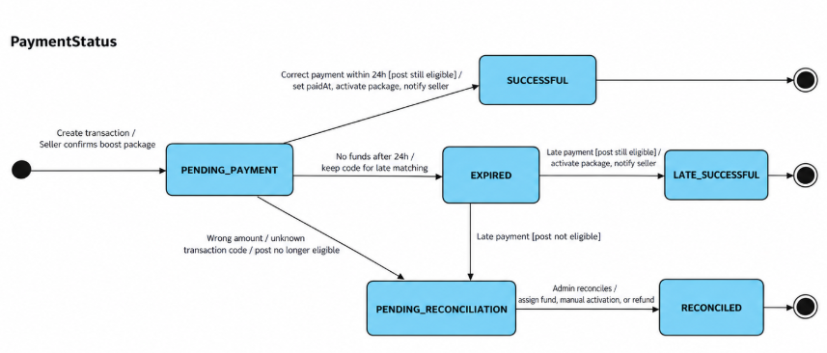
Stage | State | Actor | What happens
1. Creation | Initial → PENDING_PAYMENT | Seller | The Seller selects an eligible post and confirms a boost package (1, 7, or 30 days). The system creates a BoostTransaction with a unique transaction code, locked price, and QR payment information. The transaction starts in PENDING_PAYMENT.
2. Waiting for payment | PENDING_PAYMENT | Seller | The system displays the QR code, exact payment amount, transaction code, and 24-hour payment deadline. The Seller transfers the money using the provided information.
3a. Payment successful | PENDING_PAYMENT → SUCCESSFUL | Payment Gateway / System | The Payment Gateway confirms that the correct amount was received within 24 hours. If the post is still eligible, the system records paidAt, updates paymentStatus to SUCCESSFUL, activates the boost package, and notifies the Seller.
3b. Payment expired | PENDING_PAYMENT → EXPIRED | System | If no payment is received within 24 hours, the hourly scheduled job changes paymentStatus to EXPIRED. The transaction information is retained so that late payments can still be matched.
3c. Payment requires reconciliation | PENDING_PAYMENT → PENDING_RECONCILIATION | Payment Gateway / System | If a payment has an incorrect amount or the post is no longer eligible, the system records the incoming payment and changes the transaction to PENDING_RECONCILIATION for Administrator review.
4a. Late payment successful | EXPIRED → LATE_SUCCESSFUL | Payment Gateway / System | If the payment arrives after the deadline with the correct transaction code and amount, and the post is still eligible, the system changes paymentStatus to LATE_SUCCESSFUL, activates the package, and notifies the Seller.
4b. Late payment requires reconciliation | EXPIRED → PENDING_RECONCILIATION | Payment Gateway / System | If a late payment is received but the post is no longer eligible or the payment amount is incorrect, the transaction moves to PENDING_RECONCILIATION for manual handling.
5. Payment reconciliation | PENDING_RECONCILIATION → RECONCILED | Admin | The Administrator reviews the payment information and resolves the issue by assigning the fund, manually activating an eligible boost package, or recording a refund. The system updates paymentStatus to RECONCILED and records the reconciliation result.
6. End of payment lifecycle | SUCCESSFUL / LATE_SUCCESSFUL / RECONCILED | None | These are the final payment states. No further paymentStatus transitions occur. The transaction record is retained for payment history, reconciliation, and reporting.

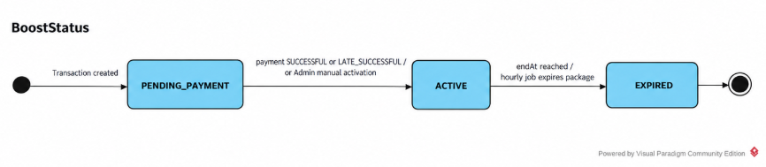

Stage | State | Actor | What happens
1. Creation | Initial → PENDING_PAYMENT | Seller / System | When the Seller confirms a boost package, the system creates the BoostTransaction with boostStatus set to PENDING_PAYMENT. The package has not been activated because payment is not yet confirmed.
2. Waiting for activation | PENDING_PAYMENT | Systemr | The boost package remains inactive while waiting for successful payment or manual activation by the Administrator. The post does not receive priority display during this stage.
3. Boost activation | PENDING_PAYMENT → ACTIVE | Payment Gateway / System / Admin | When paymentStatus becomes SUCCESSFUL or LATE_SUCCESSFUL, the system activates the package if the post is eligible. The Administrator may also activate the package after reconciliation. The system records startAt and calculates endAt based on the selected package duration.
4. Active boost period | ACTIVE | System | The post receives priority placement in search results during the active boost period. The system records the number of views and interactions so the Seller can track the package's effectiveness.
5. Boost expiration | ACTIVE → EXPIRED | System | When the current time reaches endAt, the hourly scheduled job changes boostStatus to EXPIRED. The post stops receiving priority placement, and the Seller receives a notification.
6. End of boost lifecycle | EXPIRED | None | The boost package has completed its active period and cannot be reactivated. The transaction and performance statistics remain available in the Seller's purchase history. To boost the post again, the Seller must create a new BoostTransaction.
5. Payment reconciliation | PENDING_RECONCILIATION → RECONCILED | Admin | The Administrator reviews the payment information and resolves the issue by assigning the fund, manually activating an eligible boost package, or recording a refund. The system updates paymentStatus to RECONCILED and records the reconciliation result.
6. End of payment lifecycle | SUCCESSFUL / LATE_SUCCESSFUL / RECONCILED | None | These are the final payment states. No further paymentStatus transitions occur. The transaction record is retained for payment history, reconciliation, and reporting.

c. Order State Diagram

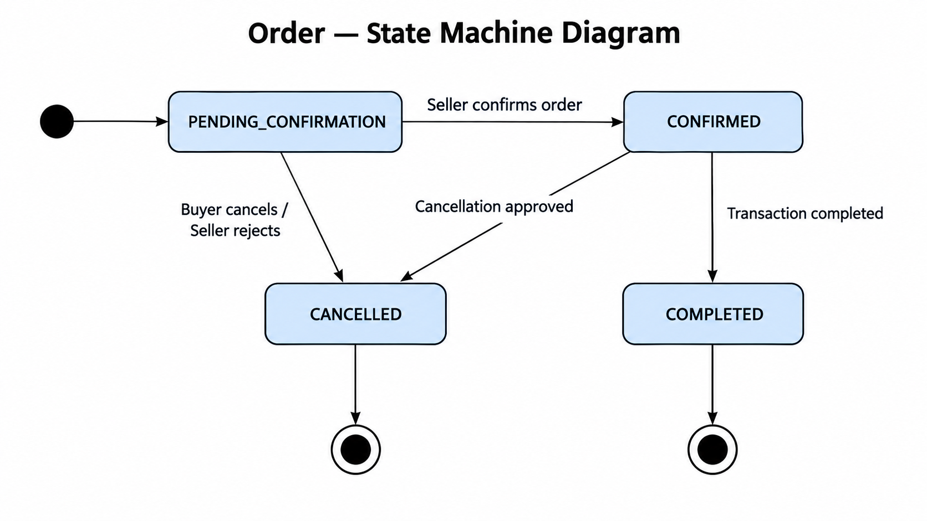

Stage | State | Actor | What happens
1. Order creation | Initial → PENDING_CONFIRMATION | Buyer / System | The Buyer selects a post and places an order. The system creates a new Order, records the buyer and seller information, order details, and relevant transaction information. The order starts in PENDING_CONFIRMATION.
2. Waiting for confirmation | PENDING_CONFIRMATION | Seller / System | The system notifies the Seller about the new order. The Seller reviews the order details and decides whether to accept or reject the order. While waiting for a decision, the order remains in PENDING_CONFIRMATION.
3a. Order confirmed | PENDING_CONFIRMATION → CONFIRMED | Seller / System | If the Seller accepts the order, the system updates the order status to CONFIRMED and notifies the Buyer. The parties can then proceed with the transaction and arrange the delivery or handover of the item.
3b. Order cancelled or rejected | PENDING_CONFIRMATION → CANCELLED | Buyer / Seller / System | If the Buyer cancels the order before confirmation or the Seller rejects it, the system updates the order status to CANCELLED and notifies the relevant parties. The order process ends without completing the transaction.
4a. Transaction completed | CONFIRMED → COMPLETED | Buyer / Seller / System | After the item has been successfully handed over and the transaction is completed, the system updates the order status to COMPLETED. The order is considered successfully finished, and no further status transitions are expected in the normal lifecycle.
4b. Confirmed order cancelled | CONFIRMED → CANCELLED | Buyer / Seller / Administrator / System | If a cancellation request is permitted under the system's business rules and is approved, the system updates the order status to CANCELLED and notifies the relevant parties. The transaction does not proceed to completion.

d. PostEdit State Diagram

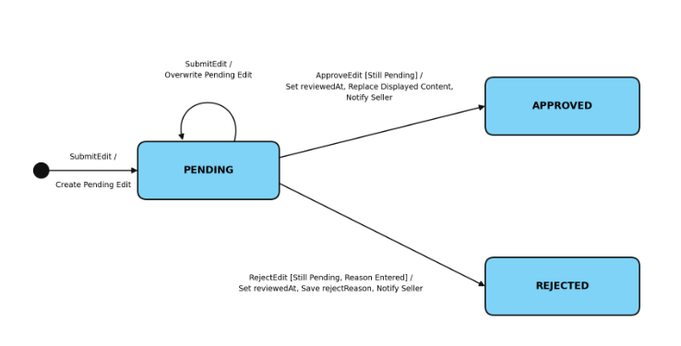

Stage | State | Actor | What happens
1. Creation | Initial → PENDING | Seller | The Seller edits the title, description, images, category or tags of an approved post and saves the changes. The system validates the data, creates a pending edit, keeps the approved version visible to the public and tells the Seller that the changes are awaiting approval.
2. Waiting for review | PENDING | Admin | The edit appears in the “Edit versions” group of the moderation queue, oldest first. The Admin reviews the current content next to the proposed content, with the differences highlighted.
2b. Edited again | PENDING → PENDING | Seller | If the Seller edits the post again before the Admin decides, the new edit overwrites the pending one, so there is only one pending edit per post.
3a. Edit is approved | PENDING → APPROVED | Admin | The edited content replaces the content that is currently displayed and the post stays visible. The system records “reviewedAt” and notifies the Seller in the app.
3b. Edit is rejected | PENDING → REJECTED | Admin | The Admin must enter a reason. The displayed content stays unchanged, the system records “reviewedAt” and “rejectReason”, and notifies the Seller in the app with the reason.
4. End of lifecycle | APPROVED or REJECTED | None | The edit does not move on and is never reopened. The record is kept as history. To change the post again, the Seller creates a new edit, which starts again from the initial state.

e. IncomingFund State Diagram
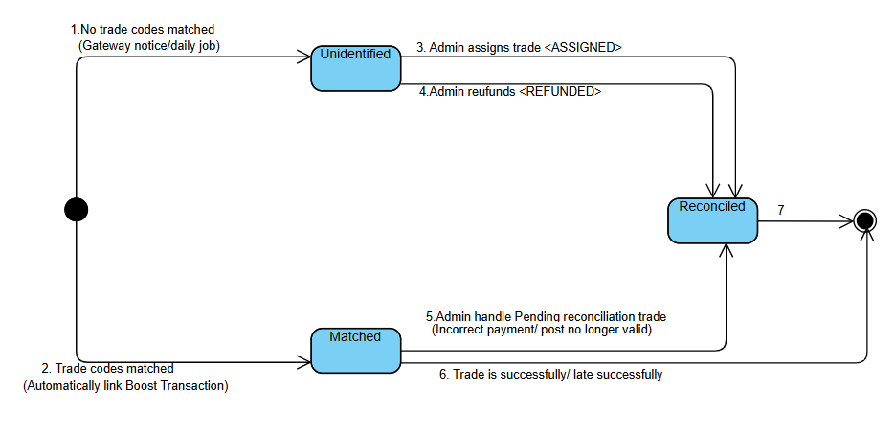

Stage | State | Actor | What happens
1. Creation | UNIDENTIFIED | Payment Gateway / Banking System | The payment gateway sends a notification regarding funds actually deposited into a bank account . The system creates a new 'IncomingFund' record containing the following information: amount, transfer description, and gateway reference code (gatewayRefCode), with an initial status set to 'UNIDENTIFIED'
2. Waiting for activation | UNIDENTIFIED | System / Admin | The funds are currently in a "pending match" status. The system automatically scans to determine whether the gatewayRefCode or the payment reference/description matches any pending BoostTransaction
3. Fund matching / assignment | UNIDENTIFIED $→$ MATCHED | System / Seller | If matching information (transaction code, amount) is found, the system automatically links this payment to the corresponding transaction via an "is matched to" relationship and updates its status to MATCHED
4. Payment reconciliation & resolution | MATCHED $→$ RECONCILED | Admin | The admin performs periodic cash flow reconciliation. They determine the appropriate resolution (ASSIGNED or REFUNDED), update the reconciledAt timestamp, and change the fund status to RECONCILED
5. End of fund lifecycle | RECONCILED $→$ End | System | The funds have been fully reconciled and tightly integrated with the system’s accounting/transaction data, concluding the processing lifecycle for an inbound cash flow.

f. ViolationReport State Diagram
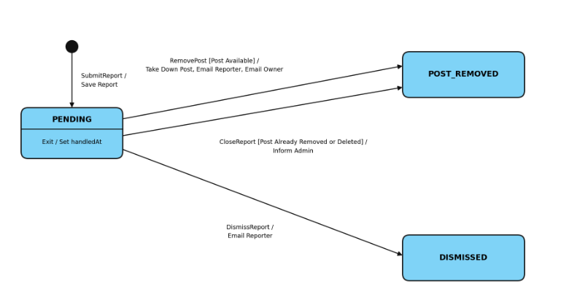

Stage | State | Actor | What happens
1. Creation | Initial → PENDING | Buyer or Seller | The user submits a report with a reason. The system saves it and records “createedAt”.
2. Waiting for review | PENDING | Admin | The Admin reviews the details and makes a decision.
3a. Report is valid | PENDING → POST_REMOVED | Admin | The Admin removes the post. The system emails the reporter and the post owner.
3b. Report is invalid | PENDING → DISMISSED | Admin | The Admin dismisses the report. The post stays unchanged and the system emails the reporter.
3c. Post no longer available | PENDING → POST_REMOVED | System | The system informs the Admin that no action is needed and closes the report.
4. End of lifecycle | POST_REMOVED or DISMISSED | None | The report does not move on and is never reopened. The record is kept as history.

IV. Design specification

IV.1 Integrated Communication Diagrams

- Account management Integrated Communication Diagrams
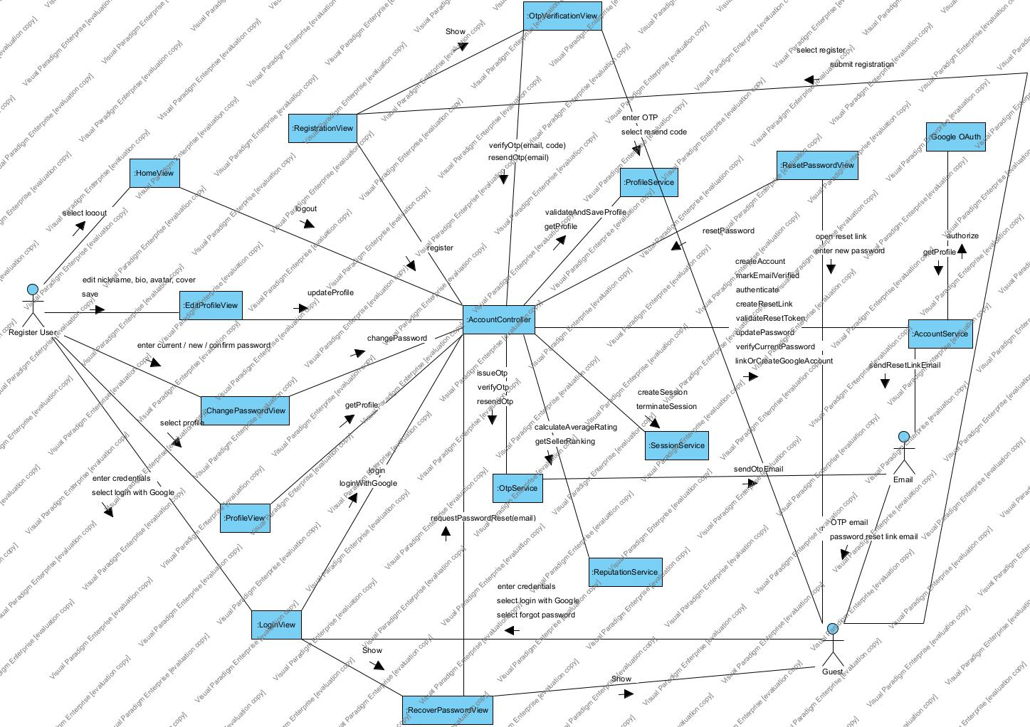

IV.2 System High-Level Design

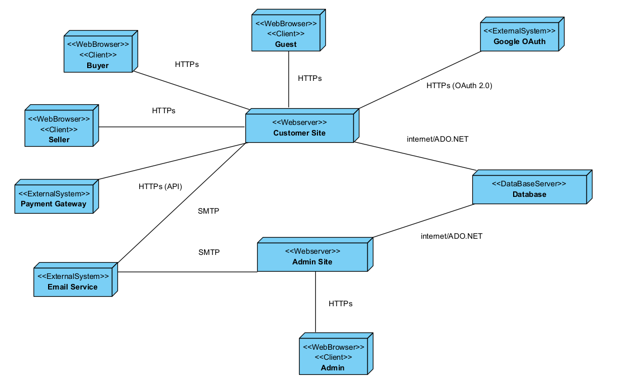

V. Implementation

V.1 Map architecture to the structure of the project

V.1 Map Architecture to the Structure of the Project

1. Overview of the Chosen Architecture
Architectural style. Hola Student Marketplace (HSM) uses a three-tier Client/Server architecture (Frontend – Backend – shared MySQL relational database). The backend is a Modular Monolith in the Component-Based style:
- The core business logic is organized into independent, feature-based modules that are always enabled.
- Three optional features (Post Boost and Payment, Chat, and Notification) each expose their own interface and can be switched on or off through configuration.
- External services (Email, Google OAuth, Payment Gateway) are placed behind dedicated adapters.
Code-organization alternatives considered.
Criteria | (1) Technical layering (Layered) | (2) Feature-based decomposition | (3) Event-Driven
Folder organization | By technical role (controllers/, services/, repositories/) | By business domain (order/, product/, user/, ...) | Fully separated, independent services/modules with message-handling components
Reference architectural pattern | Layers of Abstraction | Modular Monolith / Component-Based | Asynchronous Message Communication
Feature cohesion | Low (code of one feature is scattered across several folders) | High (a feature is packaged in a single folder) | High
Initial complexity | Low; very quick for small projects | Medium; requires a standard folder convention | High; requires a message broker (e.g., RabbitMQ/Kafka)
Maintainability and manageability as the project grows | Poor (prone to “spaghetti code”) | Good (clear boundaries, easy to divide work among team members) | Excellent (maximum decoupling, easy to scale out)
Migration path to Microservices | Difficult; requires heavy rework | Very convenient, since modules are already encapsulated | Ready
Selected solution: (2) Feature-based decomposition (Modular Monolith). The reasons are:
- Fits the project scale and team capability. It has medium complexity and a single deployment unit with one database. Solution (3) would require a message broker plus separate monitoring and operations, which exceeds the budget and skills of a student team.
- Avoids the “spaghetti code” risk of solution (1). HSM contains more than 20 entities across several business areas (accounts, posts, trading, boost, and so on). Grouping by technical role would scatter the code of a single use case across many folders.
- Supports task allocation. Each team member can own a set of modules, which reduces merge conflicts.
- Preserves transactional data integrity. Orders, payments, and status histories share one database and are updated within a single transaction, with no need for distributed transactions.
- Provides an upgrade path. Each module is already encapsulated, and the three optional features already have interfaces, so they can later be extracted into independent services if the user base grows.
Inside each module, the code is still divided into Controller → Service → Repository → Model. Layering is therefore not discarded; it is applied at the small scale within each feature.

2. Mapping to Project Structure
Project folder structure
hola-student-marketplace/
├── frontend/ # Frontend subsystem (client-side)
│ ├── src/
│ │ ├── features/ # UI is also divided by feature
│ │ │ ├── account/ # Registration, login, profile
│ │ │ ├── post/ # Post creation, search, product detail
│ │ │ ├── trading/ # Price offers, orders, complaints, reviews
│ │ │ ├── boost/ # Post boost, QR payment
│ │ │ ├── chat/ # Messaging
│ │ │ ├── notification/ # Notifications
│ │ │ └── admin/ # Post approval, report/complaint handling
│ │ └── shared/ # Shared UI components, API client
│ └── package.json
│
├── backend/ # Backend subsystem (server-side)
│ └── src/
│ ├── account/ # ── Module: Account (User, UserSanction)
│ │ ├── account.controller.ts
│ │ ├── account.service.ts
│ │ ├── account.repository.ts
│ │ └── account.model.ts
│ ├── post/ # ── Module: Post (Post, PostEdit, Category)
│ ├── community/ # ── Module: Comment, Favorite, Follow, ViolationReport
│ ├── trading/ # ── Module: PriceOffer, Order, Complaint, Review
│ ├── admin/ # ── Module: Administration (approval, configuration, logs)
│ │
│ ├── plugins/ # ── Optional features (switchable by configuration)
│ │ ├── boost/ # BoostPackage, BoostTransaction, IncomingFund
│ │ ├── chat/ # Conversation, Message
│ │ └── notification/ # Notification
│ │ (each plugin has: interface, real implementation, NoOp implementation,
│ │ controller, repository, model)
│ │
│ ├── integration/ # ── Adapters for external services
│ │ ├── email.adapter.ts
│ │ ├── google-oauth.adapter.ts
│ │ └── payment-gateway.adapter.ts
│ │
│ ├── jobs/ # ── Scheduled jobs (post expiry, order auto-cancel/complete,
│ │ # offer and boost expiry)
│ ├── shared/ # Components shared across the whole system
│ │ ├── database/ # MySQL connection, transaction handling
│ │ └── middlewares/ # Authentication, 4-role authorization, error handling
│ └── main.ts # Application entry point
│
└── database/
└── schema.sql # Physical design, MySQL 8.0


Mapping of architectural components to project modules
Architectural component | Project module | Responsibility
Client tier | frontend/src/features/*, shared/ | User interface, REST API calls, organized by feature
Server tier: always-on core | backend/src/account, post, community, trading, admin | Core business logic; each module encapsulates Controller–Service–Repository–Model
Server tier: pluggable components | backend/src/plugins/boost, chat, notification | Optional features, each with an interface, a real implementation, and a no-op implementation
External-service adapters | backend/src/integration/ | Email, Google OAuth, and Payment Gateway, each behind its own adapter
Shared components | backend/src/shared/database, middlewares | Database connection, transactions, centralized access control
Background tasks | backend/src/jobs/ | Expiry and auto-complete jobs driven by the deadlines in the database
Data tier | database/schema.sql | A single shared relational database
Dependency rules between modules
- The core calls plugins only through their interfaces. For example, trading calls NotificationService; when the plugin is disabled, NoOpNotificationService is loaded instead and the core continues to work.
- Modules communicate through each other’s Service layer and never access another module’s Repository or Model directly.
- Access control is centralized in shared/middlewares and is not duplicated in each module.
- Clear module boundaries allow a module to be extracted into a separate service later without rewriting it.

